Eleanor Gallup

1929 - 2024

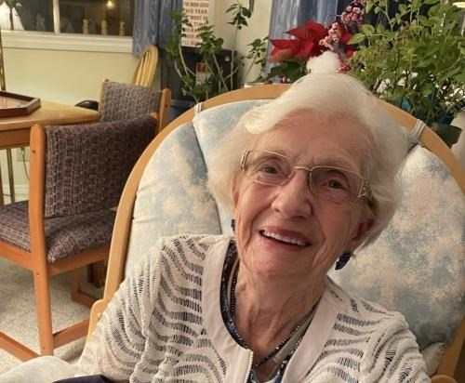

Comrades

It is with deep regret that we announce the passing of Eleanor Gallup. Eleanor had been a long time Associate member of ANAVETS Sidney Unit 302 from 2008 through 2023. She would attend many functions including meat draws and bingos. Eleanor was also one of my team players at the Miracle Lanes Bowling Alley.

Her obit follows.

In great sadness we announce the passing of Eleanor Gallup - Wife, Sister, Mother, Grandmother & Great-Grandmother. Eleanor was predeceased by her loving husband Len, her sisters Irene and Marlene, her brothers Norrie, Bill & Norm & her granddaughter Kimmy. She leaves behind her daughter Michele, sons Del & Tom, numerous grandchildren, great-grandchildren, nieces, nephews and her remaining sister Eva. There will be a family & close friends gathering on Saturday August 24th from 2-5 and Internment at a later date. The family wishes to thank all her friends from the ANAF in Sidney, Summergate Village and Trillium for their kindness over the years. Special thank you to the lovely staff on unit 6B at the Victoria General Hospital.

To plant trees in memory, please visit the [Sympathy Store](https://sympathy.legacy.com/en-ca/funeral-flowers/productdetails/?type=obituary&p=207606296&pn=eleanor-gallup&affiliateId=3129&sku=tre-ctim&pm=240).

Published by The Times Colonist from Aug. 22 to Aug. 24, 2024.